**ESP8266 library installation:**

**Connect your laptop to internet and then follow the below step to install library.**

1. Open Arduino IDE🡪go to files🡪preferences🡪additional board manager URL🡪paste the below URL in the field.

URL: <http://arduino.esp8266.com/stable/package_esp8266com_index.json>

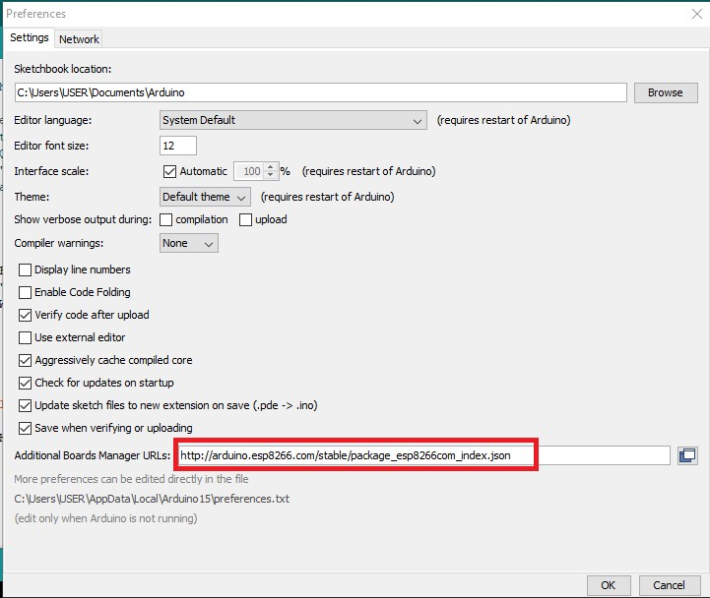

1. Once pasted click ok. then, tools🡪board🡪boards manager.

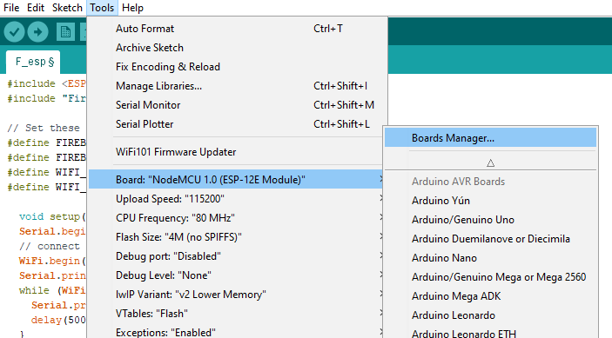

1. In pop-up window type “esp8266” in search bar and click install. Once installation is done close the IDE and restart it.

